Internet Safety: SPAM
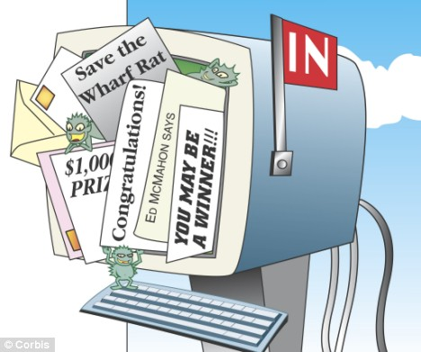

Objectives
Students will be able to:
☐ Define spam and junk mail
☐ Define scam and related terms
☐ Explore strategies for handling unwanted email messages
☐ Identify different forms of spam

Content in this lesson was adapted from: www.commonsensemedia.org, www.consumer-action.org, Microsoft Digital Literacy 2007, and www.onguardonline.gov

Discussion
- Is it okay to open emails from senders that you do not know? What about attachments?

- Have you ever seen advertisements in your email inbox?

- Read the email message below. Does anything seem strange about it?
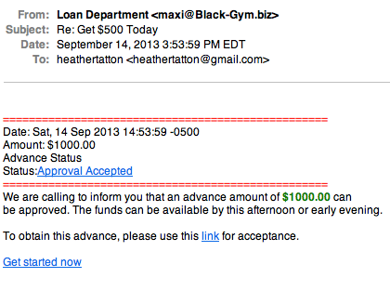
myemail@gmail.com

Write three questions or concerns that you have about this email
- _________________________________________________
- _________________________________________________
- _________________________________________________

Vocabulary
Discuss what you already know about these words and expressions below with a partner:
Expression | Definition
- Virus
- Hacker
- Malicious
- Scam
- Phishing
- Spam
- Junk Mail
- Too good to be true

As you read the following text, come back to this vocabulary list to check your definitions. Look up the vocabulary online and complete the table.
Other New Words
Expression | Definition

Be careful when opening e-mail messages with attachments.
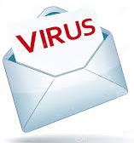
Email is used for business and personal communication. However, hackers, scams, and the people who create viruses use email for malicious reasons, which means that they want to cause damage. For example, these people can send email attachments containing dangerous software.

Email is a common way to spread viruses. Do not open e-mail with attachments from senders you do not recognize.

Do not respond to advertisements that you didn’t ask for.
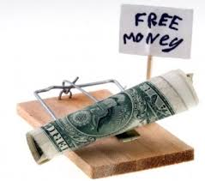
You may receive email messages from unknown senders including individuals and companies that are advertising their products or services. Their offers might be very attractive, like instant money! But if it seems too good to be true, it probably is. These messages are known as junk mail or spam.

Some junk mail is used for “phishing” or “scams” and is used for stealing identities. A phishing or scam email might ask you for your bank account number or other personal information. Therefore, you should not reply to junk mail!

Email programs, like Gmail, include a SPAM or Junk Mail folder. You can delete your spam from this folder at any time.

Don’t send financial information by email.
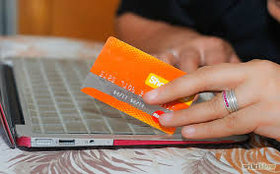
Email is not a secure method of sending financial information like your credit card, checking account, or Social Security number. If you begin a transaction and need to give your financial information through an organization's website, look for indicators that the site is secure, like a URL that begins https (the "s" stands for secure). But do not send your credit card number or bank account information by email.

Task 1 – Explore
1. Open up your Gmail account and look for where your “junk mail” or “spam” is.
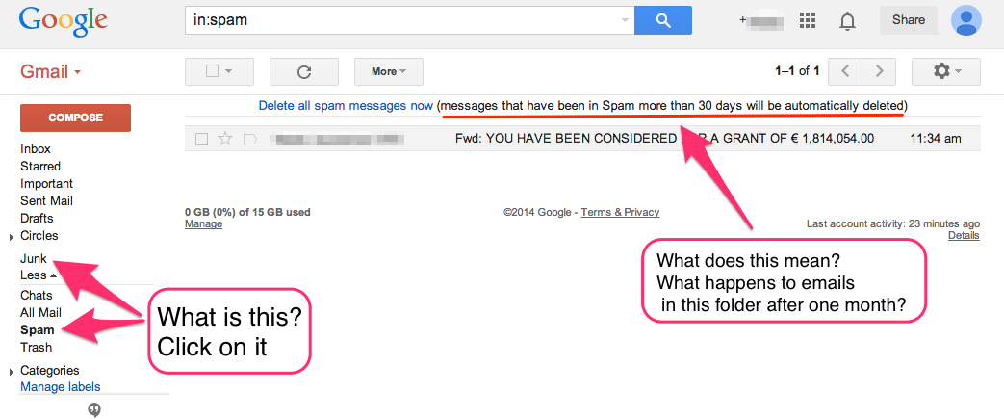
When you find it, type the steps to find Spam and Junk folders.

Step 1:

Step 2:

Step 3:

2. Open an email from your inbox. If you want to report spam, is there a way to do that?
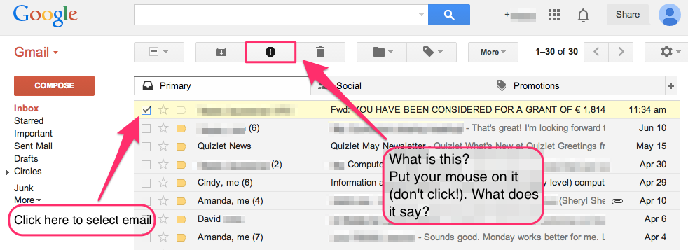
When you find it, type how to do it and show your partner.
Step 1:
Step 2:
Step 3:

Draw a picture of the REPORT SPAM icon here.

Task 2 – Example
Directions: Read the story below and write advice to Celia below.
Millie and Peter did not grow up with computers—they used typewriters and sent letters by “snail mail.” They’ve just “inherited” their daughter’s old computer. Celia thinks her parents will enjoy being able to shop and bank from home, send and receive email, and see the latest pictures of the grandkids.
Celia comes home for the weekend to set up the computer for her parents. Before she leaves Sunday, she teaches them the basics. She tells them she’ll be back next weekend to help them with any issues they run into.
Millie and Peter take to the computer like fish to water. Below is a list of activities they did on the computer during the first week. In the box to the right of each activity, note whether it is “OK” or “NOT OKAY”.
OK Or
NOT OKAY!
- Millie uses the word processing software to type up 27 of her favorite recipes. Then she emails them to her best friend.
- Peter uses his debit card to purchase a fishing rod from a private online business he came across while “surfing.”
- Peter responds to an email requesting his name, address, and credit card information in order to verify the fishing rod transaction.
- Millie emails her credit card information to their son so that he can buy a plane ticket home from college for his parents’ 35th wedding anniversary.
- Peter responds to an email from a stranger who says she will share her lottery winnings with him if he will help her claim the jackpot.
- Millie replies to an email about a Work-From-Home job. The email said that she could earn $2000 per week!

When Celia returns the following weekend, she realizes she should have given her parents more information and instruction regarding protecting their computer data and personal information.
What should Celia tell her parents?

TASK 3: Spam Email Evaluation
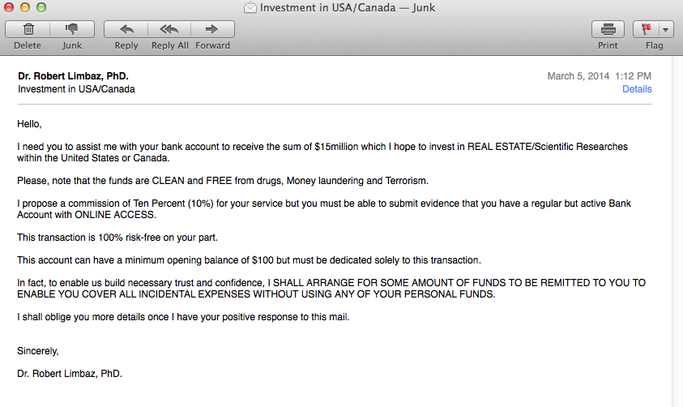

- What do you think about this email?

- Is it a good idea to reply to this email? Why or why not?

- What should you do with this email? Look at the tools (icons) on the top of the email, which one/s would you recommend using?

Follow-Up Exercises

Exercise 1: Vocabulary

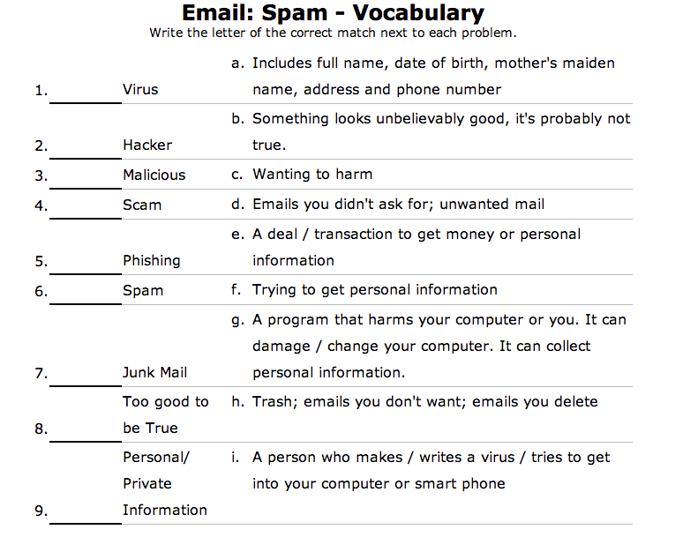www.theteacherscorner.net

Exercise 2: Questions

- What is spam?

- Write a spam email that is “too good to be true”

- What can you do if you see spam in your inbox?

Repeat & Remember

Assignment 1:
Email your teacher
- Subject: Email – Spam R&R 1
- Answer these questions in the email
- Note: Don’t forget a greeting (Hi ‘teacher’s name’) and a closing (Best, ‘your name’)
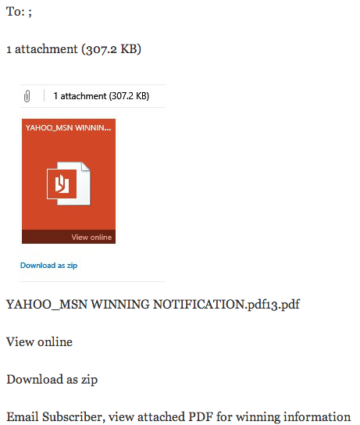
- What do you think about this email?
- Is it a good idea to reply to this email? Why or why not?
- What should you do with this email?

Assignment 2:

Email your teacher
- Search online for example spam emails
- Compose a new email to your teacher including 2 links
- Explain in email: Why are those emails spam?

