Google Drive: Document (Teacher’s Guide)

Objectives
Students will be able to:
- Understand how to access Google Drive as part of their email (Gmail) account.
- Understand how to use Google Drive on multiple devices (cloud storage)
- Create a document
- Navigate a document
- Enter text
- Select text
- Insert a picture

Class Details
- SPL 3, 4; NRS Low Intermediate
- Estimated time: 4-8 hours
- Assumptions:
- Email accounts through Google
- Ability to download photos sent through email

Vocabulary/Background
Vocabulary: Teacher should become familiar with the vocabulary and how best to explain them.
Discussion: Below is an example of how the discussion can be led.
- T: “What is Google?”
Ss will reply most often with: google.com, Internet, find information etc. Note words on board.
- T: “What else?”
Ss often don’t have an idea.
- T: “Is Google something on your computer or is it a company?”
Many Ss may not know Google is a company. Introduce Google as a company that makes many products. Here’s a mindmap to help. It isn’t necessary to introduce all these products. Just add ones that Ss mention.
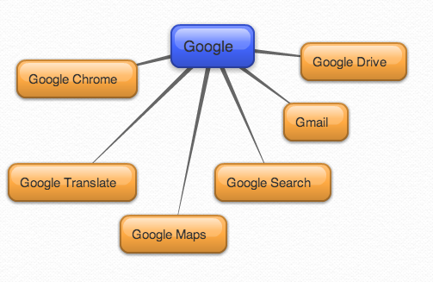
- T: “Today we will look at Google Drive.”

Tasks
- Encourage pair work and support
- Demonstrate as needed

Metaphors
- Technology Lunchbox – Gmail account is like a lunchbox with different compartments; they have already explored one part – Gmail; today they will explore another

Exit Ticket ideas
- Below are some questions that can be put on exit tickets
- Choose only 3-4 questions to put on your exit ticket and reserve 10 minutes at the end of class for this exercise.
- There are different types of questions that can be used on exit tickets. Some questions can be assessment questions (who got it and who needs more help), reflection questions (personal thoughts on the lesson), and some can be connection questions (connecting lesson to real life)
Examples:
  - How do you plan to use Google Drive?
  - What are some examples of “documents”?
  - What did you like best about the lesson today?
  - What do you want to know more about?
  - Why is it important to “sign out”?

