Google Drive: Document

Objectives
Students will be able to:
- Understand how to access Google Drive as part of their email (Gmail) account.
- Understand how to use Google Drive on multiple devices (cloud storage)
- Create a document
- Navigate a document
- Enter text
- Select text
- Insert a picture

Vocabulary
Discuss what you already know about these words with a partner:
- Google
- Email account / Gmail account
- Google Drive
- Document
- Save
- Select / Highlight
- Font
- Font size
- Font style
- Font color
- Sign in/out
- Click
- Insert
- Image

Discussion
- You want to write something down. You don't have paper or pen but you have a computer. What do you do?

- Can you write on a computer? How? Turn on the computer and show each other. Then complete the steps below.

- Step 1: Turn on the computer, log on
- Step 2: ____________________________________
- Step 3: ____________________________________

- What can you do with your email account?

Task 1 – Explore
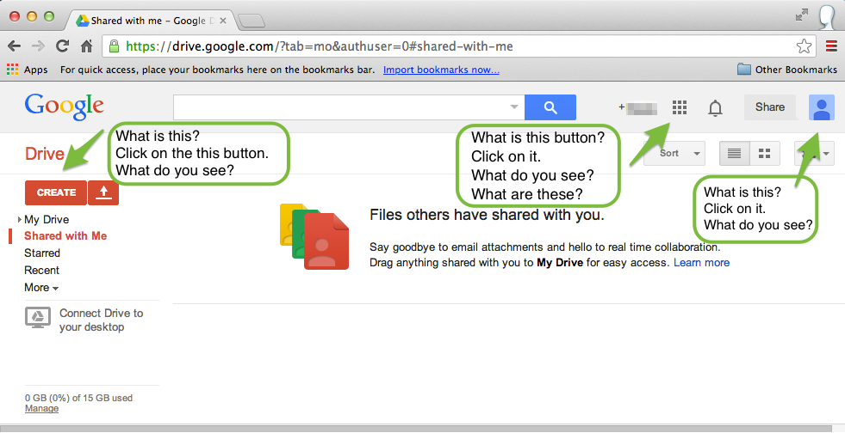

- Work with a partner to discuss the questions inside Figure 1.

- In Figure 2, what do you think will happen if “Document” is clicked?

- What do you think are documents? Is a party invitation a “document”? On the lines to the right, create a list of other types of documents.

Figure 1: Explore Google Drive

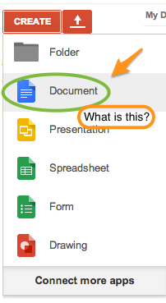
Examples of a document:
Figure 2: Explore "Create"

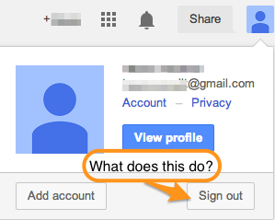
Figure 3: Explore User Icon
4. Work with a partner to discuss what “sign out” means.
Write your answer in the space provided.
To “sign out” means…

Task 2 – Party Invitation
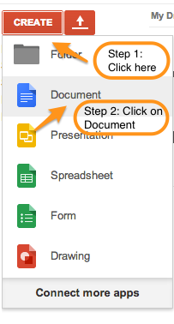

- Click on CREATE

- Click on DOCUMENT

- Create a party invitation similar to this one.

- Make the changes listed in the orange circle.

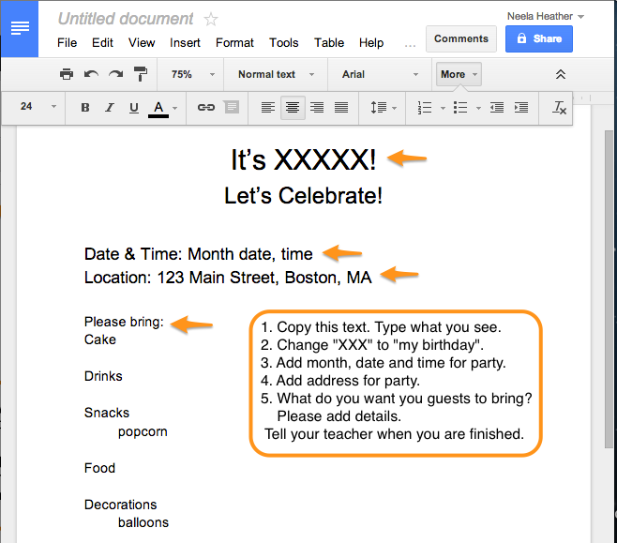

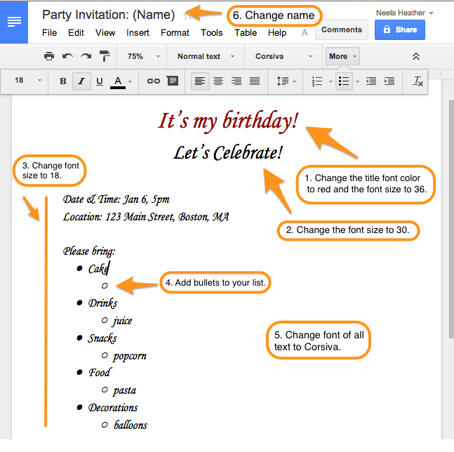

- Make the changes listed in the orange circles

You are now going to INSERT a photo!

- Click on INSERT

- Click on IMAGE

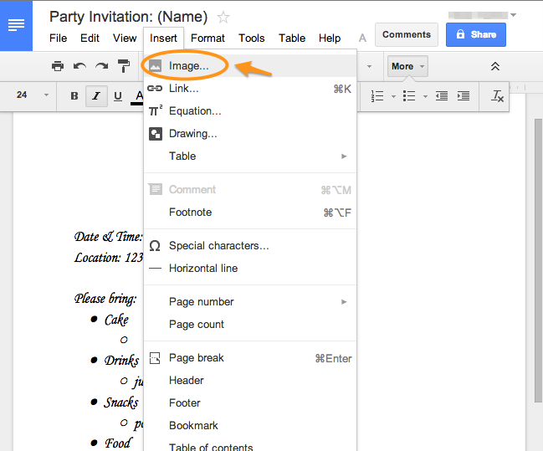

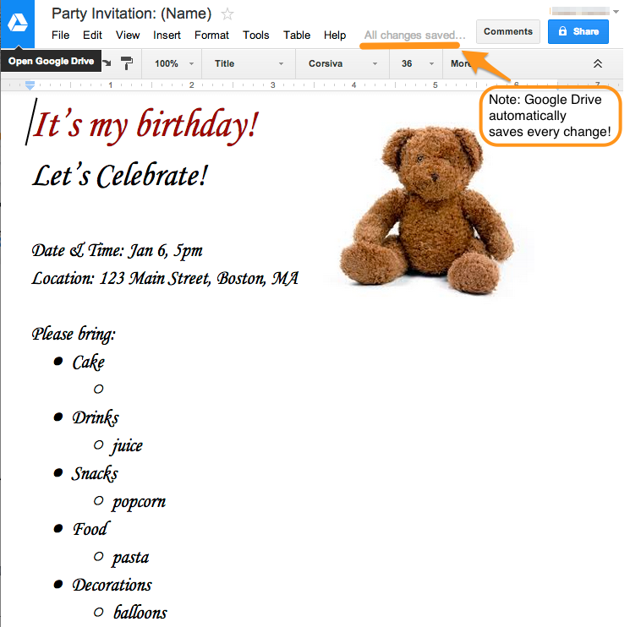
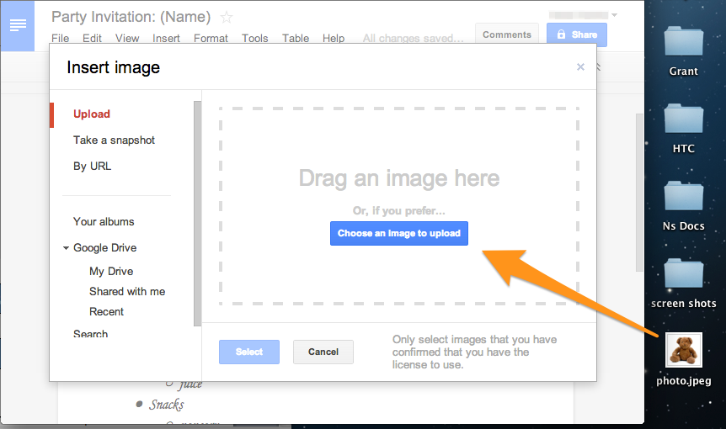
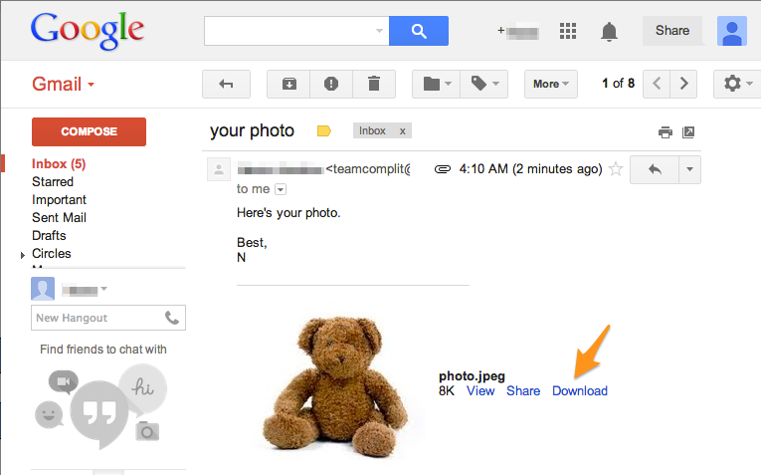

- DOWNLOAD photo from email

- INSERT photo into Google Document

CONGRATULATIONS! YOU ARE FINISHED!

Task 3 - Autobiography

- Click on CREATE

- Click on DOCUMENT

- Follow the format of this document.
  - Type your name and date
  - Change the document title at the top
  - Answer the questions.

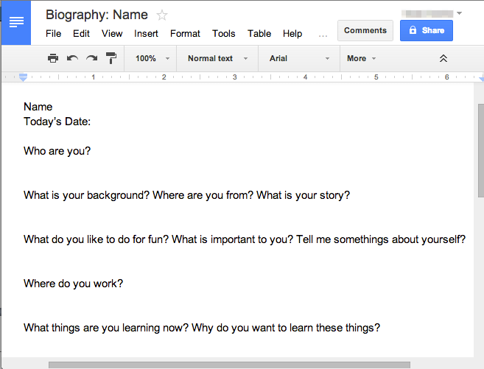

- Insert your photo

- Change font, font color, and font size

YOU ARE FINISHED! CONGRATULATIONS!

- When you are finished, always remember to sign out!

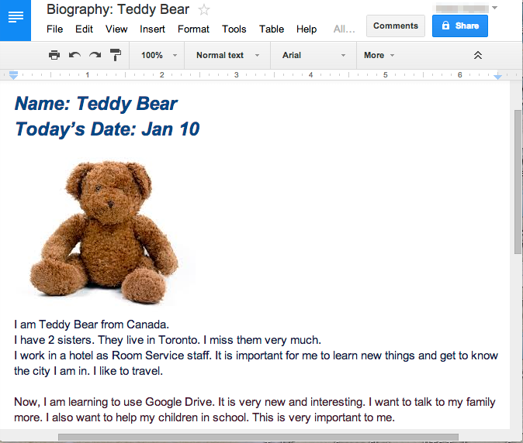
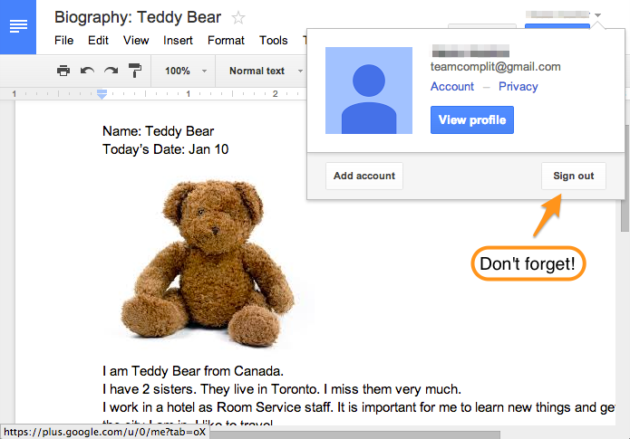

Follow-Up Exercises

Exercise 1: Vocabulary
Write the vocabulary word to complete each sentence below.

- Google
- Email /Gmail account
- Google Drive
- Document
- Save
- Select / Highlight
- Font
- Font size
- Font style
- Font color
- Sign in/out
- Click

- A file to write information in.
- Is connected to a Gmail account and we can make different types of files on it.
- Is a company that makes Gmail, Google Drive, Google Search and other software.
- Tells us how big words and letters are.
- To keep information safe on a computer. Something that you don’t need to do on Google Drive.
- Italic, bold and underline are examples of these.
- When we change the color of the words and letters, we change this.
- To connect to a Gmail account or Google Drive we first need to do this. And when we are finished, we need to do this too.
- We need this to send electronic letters to friends and family.
- This comes in many different types. Each one has a name.
- Means to press on an electronic button.
- To change the Font, Font style, Font color and Font size, we first do this to text.

Exercise 2: Google Drive Document
Please answer these questions

- What is Google Drive?

- How can you get to Google Drive? What are the steps? Please write it down.
- Step 1:
- Step 2:
- Step 3:
- What can you do on a Google Drive Document?

- Do you need to save a document in Google Drive? Why or Why not?

- Can you open your document on a different computer? Why or Why not?

- What is font?

- What is font size?

- What are the steps to changing the font size?
- Step 1:
- Step 2:
- When you are finished with your Google Drive Document, what do you do?

- How are YOU going to use Google Drive Document?

Repeat & Remember

Assignment 1:

- Create a Google Drive Document.
- Change its name to “Name’s Hometown”.
- Tell me 3 things about your hometown.

Assignment 2:

- Create a Google Drive Document.
- Change its name to “ Why use Google Drive”.
- Write about 3 situations where we can use Google Drive Documents.

