Internet Safety: Spam
(Teacher’s Guide)

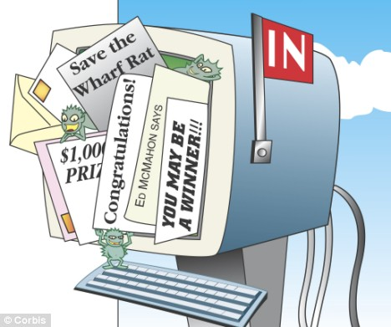

Objectives
Students will be able to:
☐ Define spam and junk mail
☐ Define scam and related terms
☐ Explore strategies for handling unwanted email messages
☐ Identify different forms of spam

Class Details
- SPL 3, 4; NRS Low Intermediate
- Estimated time: 4-8 hours
- Assumptions:
- Email accounts through Google
- Ability to login, access various folders and labels
- T has email addresses of all Ss and sends a sample Spam email to Ss before lesson.

Instruction Guidelines
- Encourage pair work and support
- Demonstrate as needed

Metaphors
- Scam – invalid calling card for discount rates to home country

Discussion (15-20 mins)
- Depending on reading level and prior knowledge may take varying amounts of time.
- Make sure Ss understand
  - It isn’t expected that they know all the answers and should skip the ones they don’t know.
  - This is just to get them thinking about the topic. They will get all the answers as they work through the unit but should definitely ask questions.
  - Their work doesn’t need to be grammatically correct.

Vocabulary/Background (15-20 mins)
Same instructions as with DISCUSSION
- Make sure Ss understand
  - It isn’t expected that they know all the answers and should skip the ones they don’t know.
  - This is just to get them thinking about the topic. They will get all the answers as they work through the unit but should definitely ask questions.
  - Their work doesn’t need to be grammatically correct.

- Teacher should become familiar with the vocabulary and how best to explain them.

Task 1: Explore (15-30 mins)
Same instructions as with DISCUSSION and VOCABULARY
- Make sure Ss understand
  - It isn’t expected that they know all the answers and should skip the ones they don’t know.
  - This is just to get them thinking about the topic. They will get all the answers as they work through the unit but should definitely ask questions.
  - Their work doesn’t need to be grammatically correct.
- T ask Ss to sign into Gmail account. They should find email from T in Inbox or Spam folder. If in Inbox, ask Ss to ‘Report Spam’. If in Spam, ask Ss why an email from T would go to Spam.
- Ss complete Explore

Introduction of Topic (45-60 mins)
Below is an example of how the discussion can be led.
- T: “Has anybody heard the word, “spam”? What could it be?
  - Ss may not have heard of this before. If they have, elicit potential meaning, asking them to predict. Accuracy isn’t important.
- go over DISCUSSION.
  - Ask about answers to questions and why they think that.
  - Go on to the email.
    - Mention that you got an email very much like this one. T ask” “What should I do with the email? Why?”
- T: “What about any of the words in the VOCABULARY section? Has anyone heard any of these words?”
- Ss may not have heard of any of the words. Elicit potential meaning if anyone has heard of a word.
- Always acknowledge answers as potential using language such as, “possibly’, “maybe”, “hmm, that’s a good idea.”, “very close”
- Next, read text
  - For lower level, read together as a class or teacher reads while Ss follow along. Go over vocabulary questions and have Ss write down the meanings in the table for new words provided; ensure all ideas are clear; make a list on board – When is an email, spam?
  - For higher level, pair Ss up and ask them to read one section; Ss come together as a class to share the main point of each section; on board, based on Ss reporting, T writes a list of how to identify email spam
- Elements identifying a spam email
  - It’s from a sender you don’t recognize
  - The subject line is suspicious (e.g. You have won!)
  - You have not subscribed to these emails
  - The sender in the body of the email doesn’t match the email address (fbi@yahoo.com)
  - The emails have errors and mistakes
  - There isn’t a personalized email greeting (Dear,)

Task 2: Example (15-30 mins)
- Read story.
  - For lower level, read together as a class or teacher reads while Ss follow along. Go over vocabulary questions; ensure all ideas are clear; give an example; have Ss work in pairs to complete the activity; make a list of Dos & Don’ts on the board together
    - E.g. Millie’s friend wants to borrow some money. Millie gives her friend the bank card and emails her friend the bank account PIN number so her friend can get some money at the ATM.
  - For higher level, ask Ss to take turns reading; clarify vocabulary; elicit something that would not be ok for Millie or Peter to do. Have Ss work in pairs to complete the activity; Ask them to write advice or Dos / Don’t for Celia’s parents.

Task 3: Spam Email Evaluation (15-25 mins)
- What do you think about this email?

- Is it a good idea to reply to this email? Why or why not?

- What should you do with this email? Look at the tools (icons) on the top of the email, which one/s would you recommend using?

Follow-up Exercises (45-60 mins)
Exercise 1: Vocabulary
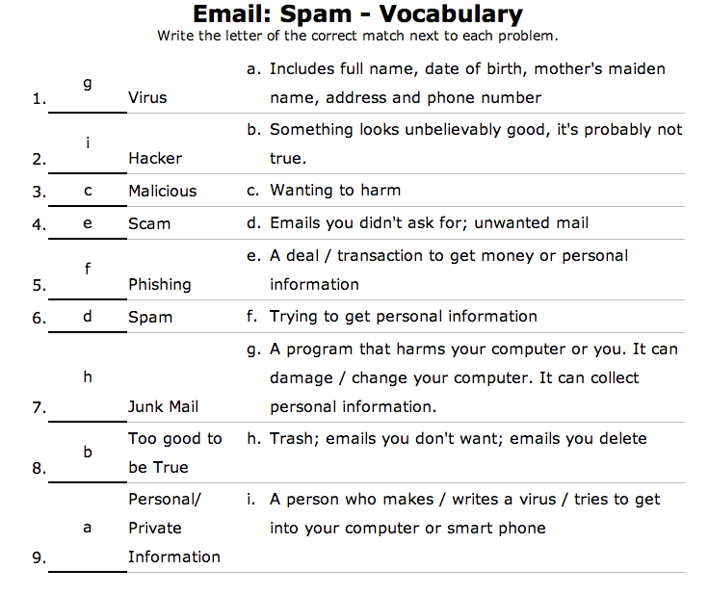
www.theteacherscorner.net

Exercise 2: Questions
- What is Spam?
- Unwanted mails
- Emails you didn’t ask for
- Write a spam email that is “too good to be true” (Can be assigned as homework)
- Encourage students to use the example they have.
- Let them know it doesn't have to be long
- Be sure to collect this work!
- What can you do if you see spam in your inbox?
- Delete it
- Report Spam
- Move to Spam folder

Exit Ticket ideas
- Below are some questions that can be put on exit tickets
- Choose only 3-4 questions to put on your exit ticket and reserve 10 minutes at the end of class for this exercise.
- There are different types of questions that can be used on exit tickets. Some questions can be assessment questions (who got it and who needs more help), reflection questions (personal thoughts on the lesson), and some can be connection questions (connecting lesson to real life)
Examples:
  - How do you know if an email is spam?
    - If it’s from a sender you don’t recognize
    - If the subject line is suspicious
    - If you haven’t subscribed to these emails
    - If the sender in the body of the email doesn’t match the email address
    - If the emails have errors and mistakes
    - If it isn’t personalized with your name
  - What do you do with spam emails?
    - Delete
    - Report spam (in Gmail)
    - Move to Spam folder
  - Why is it important to be careful opening email messages and attachments?
    - It can be a virus
    - It can verify that your email address exists
    - You may without realizing it be induced to share personal/private information
  - What did you like best about the lesson today?
  - What do you want to know more about?

Repeat & Remember (30-60 mins)
Assignment 1:
- Ss email T answering questions
Assignment 2:
- For more advanced Ss; Ss email T sending 2 links to example spam emails and explain in body of email why these are Spam.

Sample Spam Email to Send Students
From: "FOUNDATION DE FRANCE"<foundatiodefrance2014@live.co>
Subject: YOU HAVE BEEN CONSIDERED FOR AN AWARD OF $ 1,814,054.00 FROM FOUNDATION DE FRANCE
Date: May 30, 2014 6:50:19 AM EDT
To: Recipients <foundatiodefrance2014@live.co>
Reply-To: foundatiodefrance2014@gmail.co
Dear Cash Bénéficiaire,
Fondation De France has awarded your e-mail adresse a cash award
of $ 1,814,054.00 ( One million Eight Hundred and Fourteen Thousand, Fifty-Four Dollars)
in a random e-mail sélection programme of 700,000 e-mail addresses in this year's lottery programme.
Find Your qualification numbers below:
Batch Number: (E-57-10747)
Reference Code: (FDF-456-76)
This award to help people make important changements in the quality of the world because of the present mondial économique problèms.
To receive your award: send Full Noms, Adresse and Téléphone
Numbres, to our Exécutif Clearance Officier;
Dr. Louise Pierre : foundatiodefrance2014@live.co
Note that this award is guided by UN regulation. So your strict confidentiality is required. If you disclose information about this award to anyone, you will be disqualified and will not receive your award.
Félicitations!
Mrs.frances E. Presimita (Online-Cordinator)

